Week 1
Name: M.Reddy Manish Reddy
Roll no: CH.SC.U4CSE24129
Program 1:
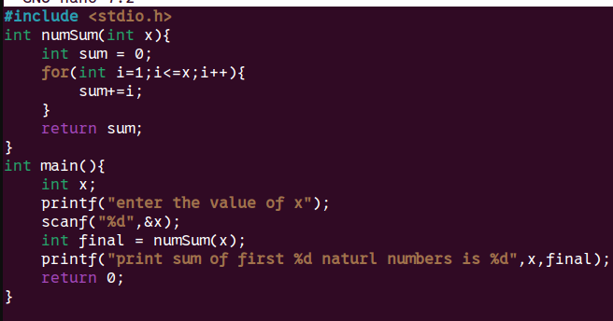
Space Complexity: O(1)
Justification for space complexity:
The program uses a fixed number of variables: x, sum, and loop counter
Since all three are integers, the total memory allocated is:
- Number of variables: 3
- Size of each int: 4 B
- Total memory required: 3 × 4 = 12 bytes
This memory requirement does not increase with the value of n.
No arrays, dynamic memory, or additional storage are used.

PROGRAM 2:
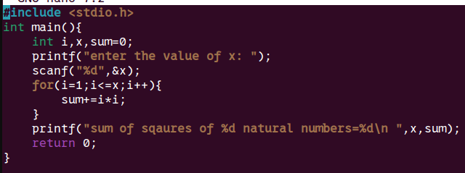
SPACE COMPLEXITY: O(1)
JUSTIFICATION FOR SPACE COMPLEXITY:
This program uses a fixed number of variables: x, i, and sum.
All of them are integers, and no extra memory such as arrays, recursion stack, or dynamically allocated memory is used.
- Number of variables → 3
- Size of each variable (int) → 4 bytes
- Total memory used → 3 × 4 = 12 bytes
Since the memory requirement does not increase with the value of n, the space usage stays constant.

PROGRAM 3:
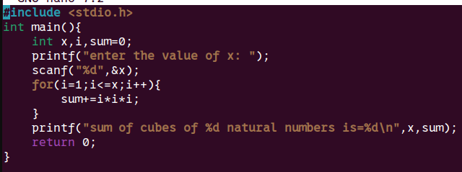

SPACE COMPLEXITY: O(1)
JUSTIFICATION FOR SPACE COMPLEXITY:
Changing the calculation from a square (i*i) to a cube (i*i*i) does not affect the amount of memory used. The program still uses only three integer variables: n (input value), i (loop counter), and sum (to store the final result). No additional storage structures like arrays, pointers, or recursion stack are introduced.
Since the number of variables remains constant and does not change based on the input size, the memory usage stays fixed.

PROGRAM 4:
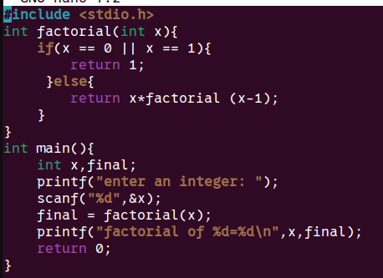
SPACE COMPLEXITY: O(1)
JUSTIFICATION FOR SPACE COMPLEXITY:
In this program, recursion is used to calculate the factorial. The function repeatedly calls itself until it reaches the base condition. For each recursive call, a new function frame is stored in the call stack. The number of recursive calls depends on the input value x.

PROGRAME 5:
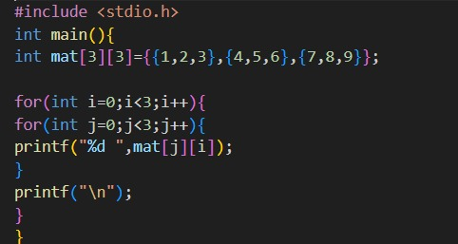
SPACE COMPLEXITY: O(1)
JUSTIFICATION FOR SPACE COMPLEXITY:
- Total elements in matrix = 3 × 3 = 9 integers
- Size of each integer = 4 bytes
- Memory used for matrix = 9 × 4 = 36 bytes
- Loop variables: i and j → 2 integers → 2 × 4 = 8 bytes
So total memory = 36 + 8 = 44 bytes (constant memory)
Since the memory does not scale with any variable input size and remains fixed, the program uses constant space.

PROGRAME 6:
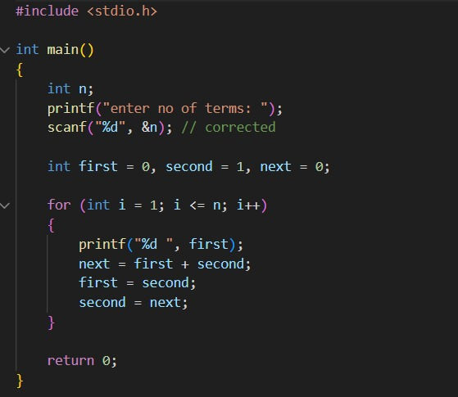

SPACE COMPLEXITY: O(1)
JUSTIFICATION FOR SPACE COMPLEXITY:
The program uses a fixed number of variables: n, the loop counter I , and three integer variables (first, second, and next) for generating Fibonacci numbers. No arrays, dynamic memory allocation, or recursive function calls are used. The amount of memory required remains constant and does not depend on the value of n.
- Number of integer variables: 5
- Size of each integer: 4 bytes
- Total memory usage: 5 × 4 = 20 bytes (constant)
Since the memory usage does not grow with input size, the space requirement remains the same regardless of how many Fibonacci terms are printed.

